**ASSIGNMENT-2**

What actually is personalized marketing?

The practice of using analytics to make advertising messages and product experiences feel unique to each customer. Personalized marketing is much more than just inserting the customer’s name into the same marketing email that goes to all of your customers. It’s about reaching the right person with the right message at the right moment with the right suggestions.

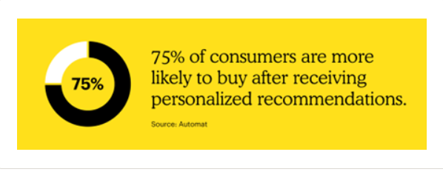

Personalized marketing trends

As companies have become more familiar with this strategy, personalization has affected many forms of communication with customers. Here are a few recent trends:

* Personalized emails: Emails that have personalized subject lines are [50%](https://docs.google.com/document/d/1jweikBjVxsB_N86YLL1rHviTE0wwjCrs9A2A3PcWsvI/edit?usp=sharing) more likely to be opened
* Less generic advertising: With the rise of personalization, consumers are becoming increasingly less accepting of generic ads: Impersonal shopping experiences frustrate [nearly three-quarters of customers](http://grow.segment.com/Segment-2017-Personalization-Report.pdf). On the other hand, [over 70% of shoppers](https://smarterhq.com/blog/personalization-statistics-roundup) respond to marketing only when it’s customized to their interests.
* Personalized product recommendations: [75%](https://automat.ai/resources/why-you-need-better-product-recommendations/) of consumers are more likely to buy after receiving personalized recommendations.

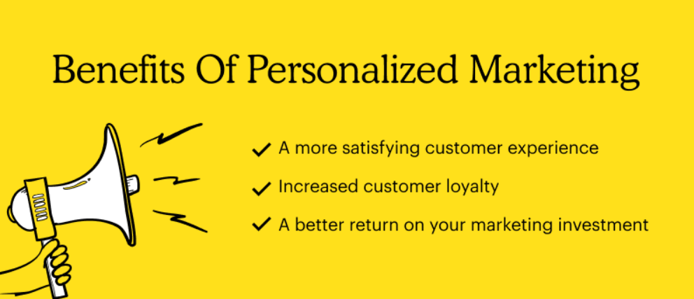

In case of most personalized marketing, the targeted market is small and medium sized entrepreneurs, non-profit organizations, emerging businesses as with limited resources, they need affordable solution for high cost of personalised marketing and content generation for the same.

Problem: High-cost personalized marketing and content generation for the same.

Solution: A generative AI based startup, which generates advertising content for individual user customized according to their interest. The software with minimal manual input can generate huge amount of content and deliver them to potential customers.

Keeping this on mind we are gonna talk about an organic skincare product which falls under the category of coconut oil.

MARKETING STRATEGY:

* Positioning: It is a skincare and wellness product for everyone.
* Segmentation: This Oil is an organic product available to everyone at affordable rates.
* Targeting: We are mainly targeting three segments –

1. The new youth.
2. Skincare enthusiasts.
3. The elderly and the loyal customers.

* Differentiation: This is a pure and unadulterated product suitable for every skin type. The new aesthetics and packaging are a huge part of the brand communication.

Identifying Target Market:

The customer segments which we identified and segregated into three categories are as follows:

* The Enthusiasts(18-28years)
* The Conventional (29-50years)
* The Seniors (50years and above)

We are also targeting, all those companies with profit of more than one crore and spend at least 20% of their income on advertising.

USER PERSONA:

Overall, Samantha is a driven and confident professional who values self-care and strives to maintain healthy, beautiful hair. She seeks a hair oil brand that aligns with her values, addresses her hair concerns, and fits seamlessly into her busy lifestyle.

**Preferred Channels:** Samantha is active on social media platforms like Instagram and YouTube, where she follows beauty influencers and seeks recommendations for hair care products. She also reads beauty blogs and magazines to stay updated on the latest trends and innovations in the industry. Samantha appreciates brands that provide informative content and engage with their customers through social media platforms.

**Challenges:** Samantha faces the challenge of finding a hair oil that meets her specific needs. With so many options available in the market, she often feels overwhelmed and unsure about which product to choose. Additionally, her frequent travels require a hair oil that is travel-friendly and can withstand different climates and environmental conditions.

**Goals and Aspirations:** Samantha's main goal is to maintain healthy and vibrant hair that complements her professional appearance. She aims to find a hair oil that not only addresses her specific hair concerns but also fits seamlessly into her existing beauty routine. Samantha aspires to be a role model for others.

model for others, promoting self-care and confidence through her own grooming habits.

**Lifestyle:** As a busy professional, Samantha leads a fast-paced lifestyle. She is constantly on the go, attending meetings, networking events, and traveling for work. Despite her hectic schedule, she prioritizes self-care and dedicates time for her beauty regimen. She prefers high-quality products that are convenient to use and provide visible results.

AGE: 34

FAMILY: Husband

OCCUPATION: Marketing Executive

**Hair Type and Concerns:** Samantha has long, wavy hair that she loves to style and experiment with. However, due to frequent styling, her hair is prone to dryness, frizz, and split ends. She also experiences occasional hair fall and is seeking products that can address these concerns while nourishing and rejuvenating her hair.



**Background:** Samantha is a successful marketing executive working for a leading cosmetics company. With a strong passion for personal grooming and self-care, she has developed a keen

interest in hair care products. Samantha believes that healthy, lustrous hair can greatly enhance a person's overall appearance and confidence.

Samantha Reed

MARKET SIZE:

In India, there are 100,550 companies with profit of more than one crore out of which, almost 30%of them spend at least 20% of their income on advertising. So, 30% of total companies, that is, 30,165 are our target companies that require advertisement content for individual user customized according to their interest.

COMPETITOR ANALYSIS:

All those companies which, in one way or the other, are advertising , are competitor for us .there are numerous advertising agencies in India. some of well-known of them are:

1.DDB Mudra Group

2.Dentsu Aegis Network

3.FCB Ulka Advertising Pvt. Ltd.

4.Group M Media India Pvt. Ltd.

5.Havas World Wide India Pvt. Ltd.

6.Madison Communication Pvt. Ltd.

7.McCann Erickson India Pvt. Ltd.

8.Mullen Lowe Lintas Group

9.Ogilvy & Mather Pvt. Ltd.

10.Publicis Communications India Ltd.

Branding strategies used by some of the advertising companies are as follows:

* **DDB Mudra** is a renowned advertising agency that has implemented several strategies to excel in the advertising industry. While specific strategies may vary based on the client's objectives and target audience, here are some common strategies employed by DDB Mudra and other advertising agencies:

1. *Research and Insights:* DDB Mudra invests in thorough research to understand the client's industry, target market, and consumer behaviour. This enables them to develop effective advertising strategies based on insights and data.
2. *Digital Marketing*: Recognizing the growing importance of digital platforms, DDB Mudra leverages digital marketing strategies to reach and engage with the target audience effectively. They employ techniques like search engine optimization (SEO), social media marketing, content marketing, and targeted online advertising.
3. *Emotional Branding:* DDB Mudra understands the power of emotions in advertising and often employs emotional branding strategies. By creating ads that connect with consumers on an emotional level, they can establish a deeper bond between the audience and the brand.

* **Dentsu Aegis Network** is a global advertising and marketing communications company that employs various branding strategies to help clients build and enhance their brands. Here are some branding strategies commonly used by Dentsu Aegis:

1. *Brand Identity Development:* Dentsu Aegis assists clients in developing or refining their brand identity, including the brand name, logo, tagline, and visual elements. They focus on creating a brand identity that aligns with the brand's values, resonates with the target audience, and communicates the brand's essence effectively.
2. *Storytelling and Narrative Building:* Dentsu Aegis understands the power of storytelling in branding. They help clients craft compelling brand narratives that engage and resonate with the target audience. Through storytelling, they communicate the brand's history, values, and purpose, creating an emotional connection and fostering brand loyalty.
3. *Digital Branding:* Recognizing the increasing importance of digital platforms, Dentsu Aegis incorporates digital branding strategies into their clients' campaigns. They develop digital marketing strategies, including website development, search engine optimization (SEO), social media marketing, content marketing, and online advertising, to enhance brand visibility and engagement in the digital space.

* **FCB Ulka** is a leading advertising agency known for its innovative and effective branding strategies. Here are some branding strategies commonly used by FCB Ulka:

1. *Brand Positioning:* FCB Ulka helps clients define their brand positioning by identifying their unique selling proposition (USP) and target audience. They conduct market research, competitor analysis, and consumer insights to develop a strong and differentiated brand positioning that resonates with the target market.
2. *Integrated Campaigns:* FCB Ulka creates integrated advertising campaigns that leverage multiple channels to deliver a consistent brand message. They design campaigns that span various mediums such as television, print, digital, social media, and experiential marketing, ensuring a cohesive brand experience across touchpoints.
3. *Cultural Insights:* FCB Ulka emphasizes understanding the cultural nuances and context in which the brand operates. They conduct in-depth research to gain insights into the local culture, values, and consumer behaviour. By incorporating cultural insights into their campaigns, they ensure that the brand resonates with its target audience on a deeper level.

With the above analyses we think it would be recommended to go forward with the above stated idea.

Some of the USP of the brand is that it is 100% pure, is natural, organic, pure and premium. It has an aesthetic, minimal, pleasing and fresh visual.

We should have a sincere, consistent and sentimental brand image for the target audience.

Overall, Samantha is a driven and confident professional who values self-care and strives to maintain healthy, beautiful hair. She seeks a hair oil brand that aligns with her values, addresses her hair concerns, and fits seamlessly into her busy lifestyle.

Overall, Samantha is a driven and confident professional who values self-care and strives to maintain healthy, beautiful hair. She seeks a hair oil brand that aligns with her values, addresses her hair concerns, and fits seamlessly into her busy lifestyle.